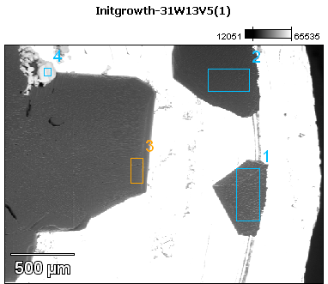

Image Name: Initgrowth-31W13V5(1)

Image Resolution: 512 by 384

Image Pixel Size: 4.95 µm

Acc. Voltage: 13.0 kV

Magnification: 50

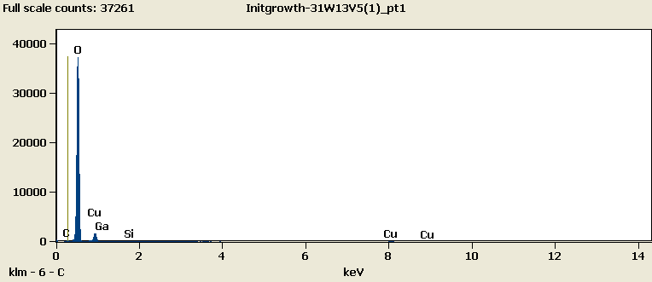

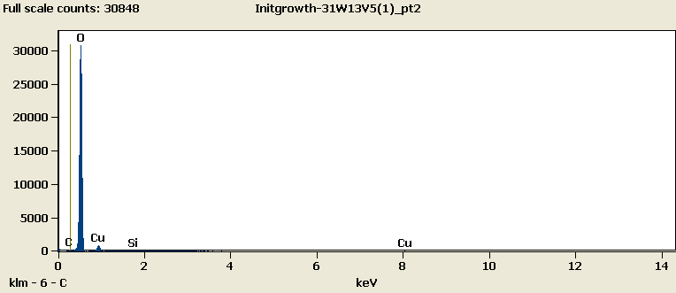

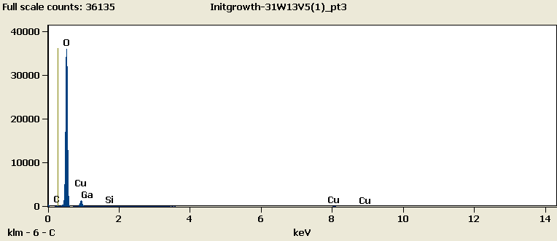

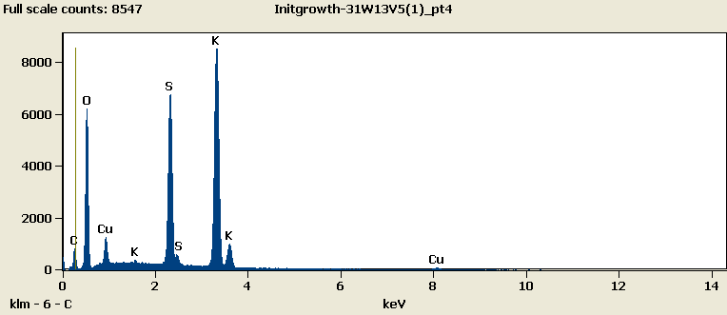

Weight %

|  |  |  |  |  |  |
| --- | --- | --- | --- | --- | --- |
|  | ***C-K*** | ***O-K*** | ***Si-K*** | ***Cu-L*** | ***Ga-L*** |
| ***Initgrowth-31W13V5(1)_pt1*** | 0.57 | 78.29 | 0.15 | 19.24 | 1.75 |
| ***Initgrowth-31W13V5(1)_pt2*** | 0.18 | 86.07 | 0.19 | 13.55 |  |
| ***Initgrowth-31W13V5(1)_pt3*** | 0.38 | 79.90 | 0.20 | 17.28 | 2.23 |
| ***Initgrowth-31W13V5(1)_pt4-No Data.*** |  |  |  |  |  |

Weight % Error (+/- 1 Sigma)

|  |  |  |  |  |  |
| --- | --- | --- | --- | --- | --- |
|  | ***C-K*** | ***O-K*** | ***Si-K*** | ***Cu-L*** | ***Ga-L*** |
| ***Initgrowth-31W13V5(1)_pt1*** | ±0.08 | ±0.25 | ±0.02 | ±0.18 | ±0.22 |
| ***Initgrowth-31W13V5(1)_pt2*** | ±0.10 | ±0.28 | ±0.03 | ±0.16 |  |
| ***Initgrowth-31W13V5(1)_pt3*** | ±0.08 | ±0.26 | ±0.02 | ±0.25 | ±0.23 |
| ***Initgrowth-31W13V5(1)_pt4-No Data.*** |  |  |  |  |  |

# Cations

|  |  |  |  |  |  |
| --- | --- | --- | --- | --- | --- |
|  | ***C-K*** | ***O-K*** | ***Si-K*** | ***Cu-L*** | ***Ga-L*** |
| ***Initgrowth-31W13V5(1)_pt1*** | 0.00 | 0.00 | 0.00 | 0.00 | 0.00 |
| ***Initgrowth-31W13V5(1)_pt2*** | 0.00 | 0.00 | 0.00 | 0.00 |  |
| ***Initgrowth-31W13V5(1)_pt3*** | 0.00 | 0.00 | 0.00 | 0.00 | 0.00 |
| ***Initgrowth-31W13V5(1)_pt4-No Data.*** |  |  |  |  |  |